cowboy

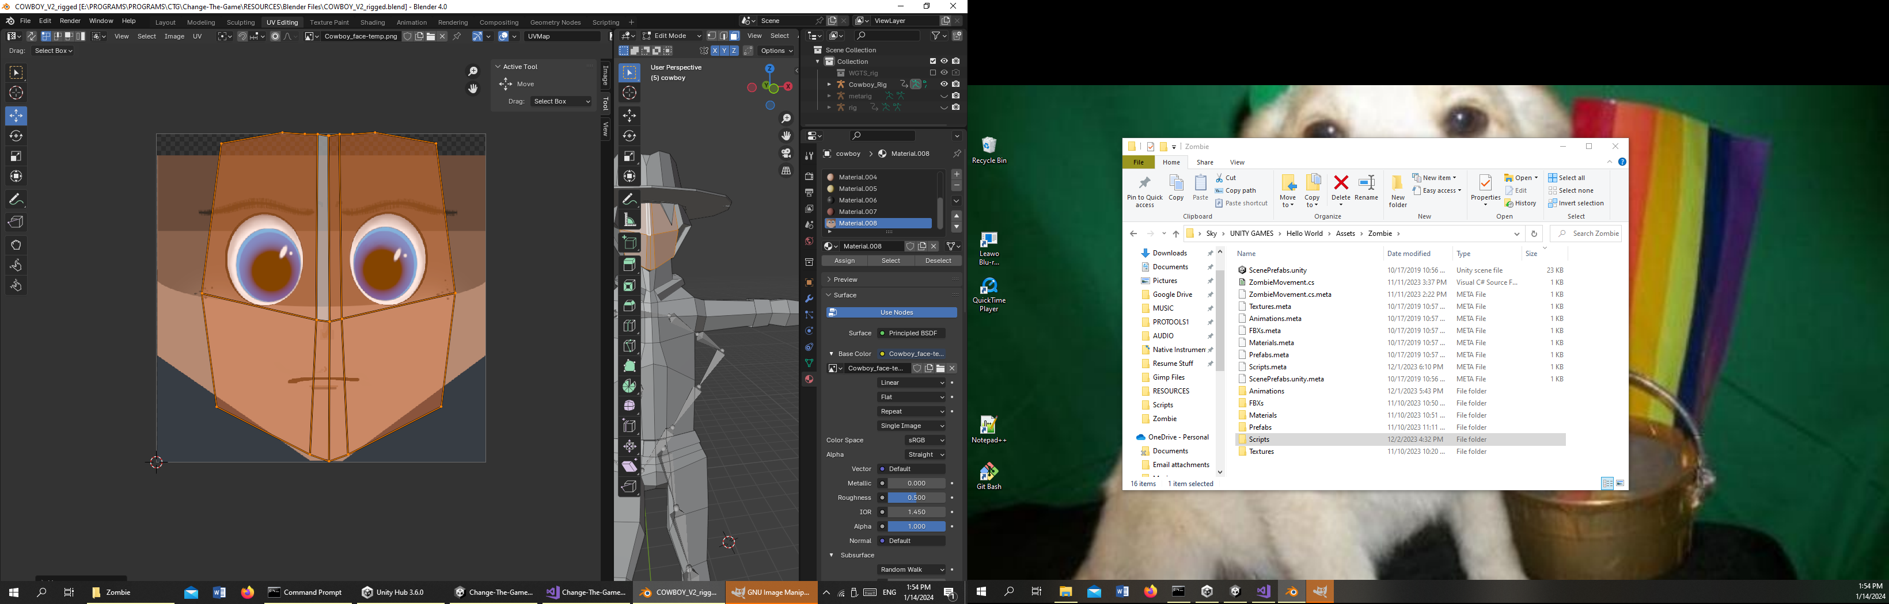

Skin: D29779

Roast

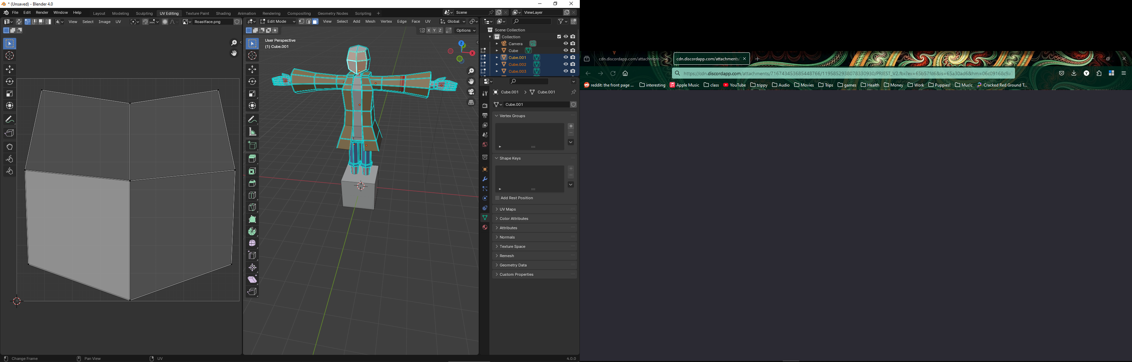

Skin : FFC5D6

Priestess

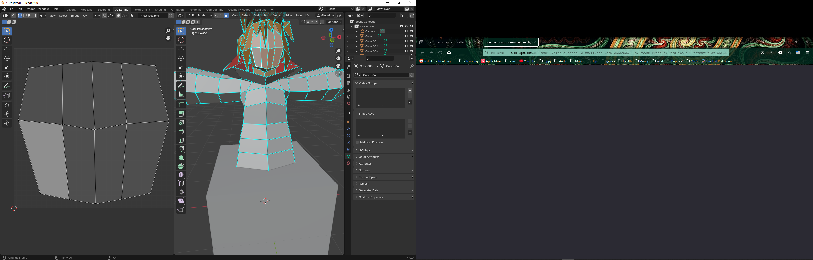

Skin E7BD85

E78F7F